NBIC-NIST MSQC Pipeline – Software for Monitoring LC-MS Performance
Netherlands Bioinformatics Centre, Proteomics Task Force, Geert Grooteplein 28, 6525 GA Nijmegen, The Netherlands.
OncoProteomics Laboratory, VU University Medical Center–Cancer Center Amsterdam, De Boelelaan 1117, 1081 HV Amsterdam, The Netherlands.

Colophon
Date | Version | Changes | Author(s)
22 Jan 2013 | 0.1 | Initial version | Pravin Pawar, Marcel Kempenaar
25 Jan 2013 | 0.2 | Added content to Part 2: User guide | Pravin Pawar, Marcel Kempenaar
17 Feb 2013 | 0.3 | Received feedback and comments from Thang | Pravin Pawar, Thang V Pham
27 Feb 2013 | 0.4 | Received contribution from Marcel | Pravin Pawar, Marcel Kempenaar
06 Mar 2013 | 0.6 | Processed comments from version 0.3 and 0.4 | Pravin Pawar
10 Mar 2013 | 0.8 | Started with MSQC Report Viewer User Manual | Pravin Pawar
18 Mar 2013 | 0.9 | Completed MSQC Report Viewer User Manual | Pravin Pawar

Table of Contents
NBIC-NIST MSQC Pipeline – Software for Monitoring LC-MS Performance 1
Table of Contents 2
Part 1: Installation Guide – NBIC NIST MSQC Pipeline 3
Description 3
Download location 3
System requirements and dependencies 3
Installation procedure 4
Running the pipeline 5
Known issues and troubleshooting 6
Part 2: User Guide – NBIC NIST MSQC Pipeline 7
Description 7
Quick Start 8
Description of Output 8
Example 1- Offline Processing Mode 8
Example 2- Online Processing Mode 11
Web output: 13
Part 3: User Guide – MSQC Report Viewer 15
Description 15
Download Location 15
System Requirements and Dependencies 15
Installation Procedure 15
Running the MSQC Report Viewer 16
Known Issues and Troubleshooting 17
Description of Output 17
References 21

Part 1: Installation Guide – NBIC NIST MSQC Pipeline

Description
Proteomics deals with the large-scale study of proteins and has become a powerful technology in discovery of drug targets and biomarkers. Modern day proteomics is largely based on nano-liquid chromatography coupled to high-resolution tandem mass spectrometry (nanoLC-MS/MS). However, the reproducibility of MS results is considered by many as insufficient. In part, inadequate quality control (QC) might be responsible for the lack of reproducibility [1]. The importance of well-established QC has become a focal point in the field of proteomics [2]. The National Institute of Standards (NIST) has developed a QC pipeline for evaluating analytical performance of a common discovery-based proteomics platform by monitoring selected output from a LC-MS/MS system. This pipeline is known as NIST MSQC Pipeline [3]. The 46 QC metrics for monitoring chromatographic performance, electrospray source stability, MS1 and MS2 signals, dynamic sampling of ions for MS/MS, and peptide identification are described in [4]. Application of these metrics enables rational, quantitative quality assessment for proteomics and other LC-MS/MS analytical applications.
The Netherlands Bioinformatics Institute (NBIC) has adapted the NIST MSQC Pipeline to suit the proteomics QC requirements of the OncoProteomics Laboratory (OPL). The adapted pipeline is named as NBIC-NIST MSQC Pipeline. Compared to the NIST MSQC Pipeline, the adapted version triggers pipeline processing on the availability of a new RAW data file in a fully automatic fashion– and creates a web-based QC report combining the NIST metrics with a number of custom metrics. This document is aimed at proteomics researchers who would like to use NBIC-NIST MSQC Pipeline in their lab for the QC of MS data.
The part 1 of this document – titled Installation Guide provides the instructions for installing the NBIC-NIST MSQC Pipeline.

Download location
Project homepage: https://trac.nbic.nl/brs2011p09/
Latest available download: https://brs.nbic.nl/ci/job/CTMM_QC/
Downloading of the files can be done by following the "Last Successful Artifacts" link pointing here: https://brs.nbic.nl/ci/job/CTMM_QC/lastSuccessfulBuild/artifact/. Downloading is done by clicking on the 'all files as zip' link. This archive contains both the QC and Apache part as well as all files of the NIST pipeline.

System requirements and dependencies
The NBIC-NIST MSQC Pipeline is designed to run on the Microsoft Windows platform. Depending on the size of RAW file, the pipeline requires higher RAM for processing larger RAW file. A rule of thumb says that the RAM requirements is app. Six times the size of RAW file. e.g. if the RAW file is 2 GB large, then 12 GB RAM is required for pipeline processing.
Table 1: System requirements and dependencies

Dependencies | Link | Explanation
ActivePerl | http://www.activestate.com/activeperl
Peptide search engine libraries | N/A | Included search engines: mspepsearch, spectrast, omssa
R (≥ 2.14.0) 64 bit | http://cran.r-project.org/
R package readMzXmlData | http://cran.r-project.org/web/packages/readMzXmlData | Reads mass spectrometry data in mzXML format
R package fields: Tools for spatial data. | http://cran.r-project.org/web/packages/fields | Fields is for curve, surface and function fitting with an emphasis on splines, spatial data and spatial statistics.
Python > 2.6 | http://www.python.org/getit/windows/ | NBIC part is written in Python
robocopy | Standard available in Windows (> XP) | Data copy from acquisition system
Xcalibur or Thermo MSFilereader | http://sjsupport.thermofinnigan.com/public/detail.asp?id=703 | Provides libraries for converting RAW files
Apache web server 2.* | http://httpd.apache.org/download.cgi | Serving the QC reports

Installation procedure
The installation procedure requires that the system requirements are followed and all the dependencies are installed. Perform instructions in Step 1 – Step 6 for installing the NBIC-NIST MSQC Pipeline.
Setup
Step 1: Download latest version (click on 'all files in zip'):
https://brs.nbic.nl/ci/job/CTMM_QC/lastSuccessfulBuild/artifact
Step 2: Extract archive to the installation folder
Step 3: Merge the 'htdocs' folder with the Apache htdocs folder
Default at: C:\Program Files (x86)\Apache Software Foundation\Apache2.*\htdocs
Create new file qc_status.log in htdocs/ctmm folder.
Add following line to the file, press Enter and save qc_status.log.
--------------------------------------------------------------------------------------
Date Filename Status
--------------------------------------------------------------------------------------
Step 4: Check and/or (Re)start Apache webserver
Check if web service is running at 'http://servername/ctmm/'
Step 5: Change location settings in 'QC/run_msqc_pipeline.py'
- _WEB_DIR pointing to the Apache htdocs/ctmm folder
- _QC_HOME pointing to the location of the extracted 'QC' folder

Running the pipeline
The NBIC-NIST MSQC pipeline is designed to operate in two modes: The offline-processing mode assumes availability of MS RAW data files in a particular directory. The online processing mode is used to run QC pipeline immediately after RAW data file is generated by LC-MS/MS method. The installation of robocopy is necessary – to copy newly generated RAW data file to pipeline RAW files directory.
Furthermore, the pipeline requires sufficient disk space – for copying RAW data file and storing intermediate data files. It is recommended to make sure that there is >25 GB disk space available at any time during the pipeline run.

Offline processing mode
For processing existing files in a directory, start QC pipeline with:
- cd <_QC_HOME>
- 'python robocopy_monitor.py <input_folder> <output_folder>' where:
  - <input_folder> contains the RAW files to process and
  - <output_folder> is used to store intermediate data files

Online processing mode
For realtime processing of files copied by Robocopy, start with:
- cd <_QC_HOME>
- 'python robocopy_monitor.py <input_folder> <output_folder> <copylog_folder>' where:
  - <copylog_folder> points to the location where Robocopy writes a logfile

Help message
- cd <_QC_HOME>
- Run 'python robocopy_monitor.py -h' to see the help message

Known issues and troubleshooting
Table 2: Known issues and troubleshooting

Issue | Pipeline Output | Troubleshooting
Python module win32serviceutil is not installed. | ImportError: No module named win32serviceutil | Download and install pywin32-214.win32-py2.7.exe from  http://sourceforge.net/projects/pywin32/?source=dlp
Python module watchdog.observers is not installed | ImportError: No module named watchdog.observers | Install watchdog package as per the following command line operations:  cd <python_dir\Scripts> e.g. <c:\Python27\Scripts>  c:\Python27\Scripts>easy_install watchdog
Access denied to folder <_WEB_DIR>\2013 while writing QC report. | WindowsError: [Error 5] Access is denied: 'C:\\Program Files (x86)\\Apache Softw  are Foundation\\Apache2.2\\htdocs\\ctmm\\2013' | Change permissions of folder <_WEB_DIR> e.g. C:\\Program Files (x86)\\Apache Software Foundation\\Apache2.2\\htdocs based on Windows 8 article described herewith: http://www.addictivetips.com/windows-tips/take-ownership-of-files-folder-and-change-permissions-in-windows-8/.  Assign Full control for the following groups: All Application Packages, System and Users.
R is installed on the system, however, path to RScript.exe not found. | 'Rscript' is not recognized as an internal or external command, operable program or batch file. | Add complete path of <R_Directory/bin> e.g. C:\Program Files\R\R-2.15.2\bin to PATH environment variable.  In Windows, configure PATH environment variable using the instructions at:  http://www.computerhope.com/issues/ch000549.htm
R package ‘fields’ not installed. | Error in library(fields) : there is no package called 'fields'  Execution halted | Open R prompt in the command prompt window. Execute following command at the R prompt to install ‘fields’ package.  install.packages("fields",repos="http://streaming.stat.iastate.edu/CRAN/")
R package ‘'readMzXmlData' not installed. | Error in library(readMzXmlData) : there is no package called 'readMzXmlData'  Execution halted | Open R prompt in the command prompt window. Execute following command at the R prompt to install ‘'readMzXmlData' package.  install.packages("readMzXmlData",repos=http://streaming.stat.iastate.edu/CRAN/”)
System RAM is not sufficient for running the pipeline. | Error: R for Windows GUI front-end has stopped working.  Error: cannot allocate vector of size 158 Kb …..  Reached total allocation of 16378Mb: see help(memory.size)  Execution halted | A rule of thumb says that the RAM requirements is app. Six times the size of RAW file. e.g. if the RAW file is 2 GB large, then 12 GB RAM is required for pipeline processing.
Disk running out of space. | Error: 1: Premature end of data in tag peaks line 564418  2: Premature end of data in tag scan line 564404  3: Premature end of data in tag msRun line 5  4: Premature end of data in tag mzXML line 2  Execution halted | Check and delete data from the <output_folder>. Free up additional disk space. It is recommended to make sure that there is >25 GB disk space available at any time during the pipeline run.
There are RAW files in the <input_folder>, however, the pipeline doesn't begin to process them. | WARNING:root:Nofiles to process | This case results if all the RAW files from <input_folder> are already processed.  Check file qc_status.log from 'Apache2.*\htdocs\ctmm' folder. Remove all the lines except the first line. Run the pipeline again.

Part 2: User Guide – NBIC NIST MSQC Pipeline

Description
The part 2 of this document – titled User Guide provides the instructions for using NBIC-NIST MSQC Pipeline. It is assumed that the pipeline is installed on the server. Refer to Part 1: Installation Guide for the installation instructions.
The NBIC-NIST MSQC pipeline is designed to operate in two modes: The offline processing mode assumes availability of MS RAW data files in a particular directory. The online processing mode is used to run QC pipeline immediately after RAW data file is generated by LC-MS/MS method. The installation of robocopy is necessary – to copy newly generated RAW data file to pipeline RAW files directory.
Furthermore, the pipeline requires sufficient disk space – for copying RAW data file and storing intermediate data files. It is recommended to make sure that there is >25 GB disk space available at any time during the pipeline run.

Quick Start

Offline processing mode
For processing existing files in a directory, start QC pipeline with:
- cd <_QC_HOME>
- 'python robocopy_monitor.py <input_folder> <output_folder>' where:
  - <input_folder> contains the RAW files to process and
  - <output_folder> is used to store intermediate data files

Online processing mode
For processing files copied by Robocopy and monitoring for new files, start with:
- cd <_QC_HOME>
- 'python robocopy_monitor.py <input_folder> <output_folder> <copylog_folder>' where:
  - <copylog_folder> points to the location where Robocopy writes a logfile

Help message
- cd <_QC_HOME>
- Run 'python robocopy_monitor.py -h' to see the help message

Description of Output

Example 1- Offline Processing Mode
This example demonstrates processing RAW file using offline mode. The following describes system setup, execution, console output and web output of processing one MS data raw file using NBIC-NIST MSQC pipeline.
- <_QC_HOME>: C:\qc-data\QCArchive17Jan\archive\QC
- <_WEB_DIR>: C:\Program Files (x86)\Apache Software Foundation\Apache2.2\htdocs\ctmm
- <input_folder>: X:\qe-raw-data
- <output_folder>: C:\qc-data\temp-output
- RAW file: QE1_121105_OPL0000_jurkat2ug_03.RAW

Console output:
Table 3: Example of console output in the offline processing mode

Output | Remark
('@Stage 1: Preparation: Copying rawfile to newinputfilename ', 'X:\\qe-raw-data\\QE1_121105_OPL0000_jurkat2ug_03.raw', 'C:\\qc-data\\temp-output\\QE1_121105_OPL0000_jurkat2ug_03.raw', datetime.datetime(2013, 3, 12, 15, 45, 34, 401000))  ('@Stage 1 completed. Input file is ', 'C:\\qc-data\\temp-output\\QE1_121105_OPL0000_jurkat2ug_03.raw', datetime.datetime(2013, 3, 12, 15, 45, 50, 668000)) | Copy raw file to <output_folder>
('@Stage 2: Preparation: Creating folder to write QC report in html form', datetime.datetime(2013, 3, 12, 15, 45, 50, 674000))  C:\Program Files (x86)\Apache Software Foundation\Apache2.2\htdocs\ctmm  ('@Stage 2 completed. Report folder is ', 'C:\\Program Files (x86)\\Apache Software Foundation\\Apache2.2\\htdocs\\ctmm\\2013\\Mar\\QE1_121105_OPL0000_jurkat2ug_03', datetime.datetime(2013, 3, 12, 15, 45, 50, 716000)) | Create folder to write QC report in html form
('@Stage 3: Conversion: Converting RAW file to mzXML format', datetime.datetime(2013, 3, 12, 15, 45, 50, 726000))  ('@Stage 3 completed. ', datetime.datetime(2013, 3, 12, 15, 46, 31, 416000)) | Convert RAW file to mzXML format and store mzXML file in <output_folder>
('@Stage 4: Running R Script on mzXML file for heatmap and TIC analysis', datetime.datetime(2013, 3, 12, 15, 46, 31, 418000))  Loading required package: methods  Loading required package: spam  Spam version 0.29-2 (2012-08-17) is loaded.  Type 'help( Spam)' or 'demo( spam)' for a short introduction and overview of this package.  Help for individual functions is also obtained by adding the  suffix '.spam' to the function name, e.g. 'help( chol.spam)'.  Attaching package: 'spam'  The following object(s) are masked from 'package:base':  backsolve, forwardsolve  Loading required package: bitops  Loading required package: digest  Loading required package: XML  2013-03-12 15:46:36 Reading mzXML file: C:\qc-data\temp-output\QE1_121105_OPL0000_jurkat2ug_03ow6zcd_QC/QE1_121105_OPL0000_jurkat2ug_03.RAW.mzXML  2013-03-12 15:48:35 Done processing mzXML file, read 28392 scans | Run R Script to read MS scans from the mzXML file
2013-03-12 15:48:35 Processing data for heatmap (min.mz: 300, max.mz: 2000, window: 17, minimum number of peaks/scan: 500)  [1] 7304  2013-03-12 15:49:20 5572 scans with more than 500 peaks have been found (76.29% out of a total of 7304 ms1 scans)  2013-03-12 15:49:20 Done preparing data, creating heatmap image..  2013-03-12 15:49:24 Done creating heatmap, saved as C:\Program Files (x86)\Apache Software Foundation\Apache2.2\htdocs\ctmm\2013\Mar\QE1_121105_OPL0000_jurkat2ug_03/QE1_121105_OPL0000_jurkat2ug_03_heatmap.[png|pdf] | Create heatmap image and save it in the <_WEB_DIR>\<year>\ <month>\<RAW_file>\ <RAW_file>_heatmap.[png| pdf] file
2013-03-12 15:49:24 Size of mzXML object = 587802008 length = 28392  2013-03-12 15:49:24 Creating total Ion count graph  2013-03-12 15:49:25 Size of ions object = 58472 length = 7304 Size of rt object = 58472 length = 7304  2013-03-12 15:49:25 Done creating total Ion count graph, saved as C:\Program Files (x86)\Apache Software Foundation\Apache2.2\htdocs\ctmm\2013\Mar\QE1_121105_OPL0000_jurkat2ug_03/QE1_121105_OPL0000_jurkat2ug_03_ions.[png|pdf] | Create total ion count graph and save it in the <_WEB_DIR>\<year>\ <month>\<RAW_file>\ <RAW_file>_ions.[png| pdf] file
2013-03-12 15:49:25 ## Metrics ##  2013-03-12 15:49:25 Number of MS1 scans: 7304  2013-03-12 15:49:25 MS1 scans containing peaks: 7304  2013-03-12 15:49:25 Number of MS2 scans: 21088  2013-03-12 15:49:25 MS2 scans containing peaks: 21088  2013-03-12 15:49:25 Writing logfile to C:\qc-data\temp-output\QE1_121105_OPL0000_jurkat2ug_03ow6zcd_QC/QE1_121105_OPL0000_jurkat2ug_03.RLOG  ('@Stage 4 completed. ', datetime.datetime(2013, 3, 12, 15, 49, 26, 56000))  ('@Stage 5: Calculating QC metrics values', datetime.datetime(2013, 3, 12, 15, 49, 26, 61000))  WARNING:root:NIST metrics file does not exist  ('@Stage 5 completed. ', datetime.datetime(2013, 3, 12, 15, 49, 26, 149000)) | Calculate following QC metrics:  a. File Size (MB)  b. Number of MS1 scans/ MS1 scans containing peaks  c. Number of MS2 scans/ MS2 scans containing peaks  d. QC pipeline run date  e. Runtime for the complete processing of RAW file
('@Stage 6: Creating metrics report in ', 'C:\\Program Files (x86)\\Apache Software Foundation\\Apache2.2\\htdocs\\ctmm\\2013\\Mar\\QE1_121105_OPL0000_jurkat2ug_03', datetime.datetime(2013, 3, 12, 15, 49, 26, 152000))  ('@Stage 6 completed. ', datetime.datetime(2013, 3, 12, 15, 49, 26, 198000)) | Save QC metrics report in the <_WEB_DIR>\<year>\ <month>\<RAW_file>\ metrics.json file
('@Stage 7: Cleanup temporary files from ', 'C:\\qc-data\\temp-output\\QE1_121105_OPL0000_jurkat2ug_03.raw', datetime.datetime(2013, 3, 12, 15, 49, 26, 201000))  ('@Stage 7 completed. ', datetime.datetime(2013, 3, 12, 15, 49, 26, 237000)) | Remove RAW file copied to <output_folder>
('@output : ', ('MSQC pipeline processing successfully completed for file ', 'X:\\qe-raw-data\\QE1_121105_OPL0000_jurkat2ug_03.raw')) | Pipeline processing successfully completed

Example 2- Online Processing Mode
This example demonstrates processing RAW file using online mode. The following describes system setup, execution, console output and web output of processing one MS data raw file using NBIC-NIST MSQC pipeline.
- <_QC_HOME>: C:\qc-data\QCArchive27Feb\archive\QC
- <_WEB_DIR>: C:\Program Files (x86)\Apache Software Foundation\Apache2.2\htdocs\ctmm
- <input_folder>: X:\qe-raw-data
- <output_folder>: E:\qc-data\temp-output
- <copylog_folder>: X:\gooqe-raw-data
- RAW file: QE2_120920_OPL2014_PPutida_C.raw
Console output:
Table 4: Example of console output in the online processing mode

Output | Remark
Monitoring: X:\qe-raw-data  Input Dir: X:\qe-raw-data  Output Dir: E:\qc-data\temp-output | Waiting for robocopy event in the monitoring directory. The trigger to proceed to the next stage is – any change in robocopy log file. Such change occurs when a new Raw file is copied to input directory using robocopy function.
('@Stage 1: Preparation: Copying rawfile to newinputfilename ', 'X:\\qe-raw-data\\QE1_121119_OPL0004_TSV_Hcellline_L+S_B7_8.raw', 'C:\\qc-data\\temp-output\\QE1_121119_OPL0004_TSV_Hcellline_L+S_B7_8.raw', datetime.datetime(2013, 3, 12, 15, 49, 26, 270000))  ('@Stage 1 completed. Input file is ', 'C:\\qc-data\\temp-output\\QE1_121119_OPL0004_TSV_Hcellline_L+S_B7_8.raw', datetime.datetime(2013, 3, 12, 15, 50, 4, 206000)) | Copy raw file to <output_folder>
('@Stage 2: Preparation: Creating folder to write QC report in html form', datetime.datetime(2013, 3, 12, 15, 50, 4, 213000))  C:\Program Files (x86)\Apache Software Foundation\Apache2.2\htdocs\ctmm  ('@Stage 2 completed. Report folder is ', 'C:\\Program Files (x86)\\Apache Software Foundation\\Apache2.2\\htdocs\\ctmm\\2013\\Mar\\QE1_121119_OPL0004_TSV_Hcellline_L+S_B7_8', datetime.datetime(2013, 3, 12, 15, 50, 4, 220000)) | Create folder to write QC report in html form
('@Stage 3: Conversion: Converting RAW file to mzXML format', datetime.datetime(2013, 3, 12, 15, 50, 4, 231000))  ('@Stage 3 completed. ', datetime.datetime(2013, 3, 12, 15, 53, 3, 747000)) | Convert RAW file to mzXML format and store mzXML file in <output_folder>
('@Stage 4: Running R Script on mzXML file for heatmap and TIC analysis', datetime.datetime(2013, 3, 12, 15, 53, 3, 749000))  Loading required package: methods  Loading required package: spam  Spam version 0.29-2 (2012-08-17) is loaded.  Type 'help( Spam)' or 'demo( spam)' for a short introduction  and overview of this package.  Help for individual functions is also obtained by adding the  suffix '.spam' to the function name, e.g. 'help( chol.spam)'.  Attaching package: 'spam'  The following object(s) are masked from 'package:base':  backsolve, forwardsolve  Loading required package: bitops  Loading required package: digest  Loading required package: XML  2013-03-12 15:53:05 Reading mzXML file: C:\qc-data\temp-output\QE1_121119_OPL0004_TSV_Hcellline_L+S_B7_8mrljqb_QC/QE1_121119_OPL0004_TSV_Hcellline_L+S_B7_8.RAW.mzXML  2013-03-12 16:13:08 Done processing mzXML file, read 38313 scans  Warning messages:  1: In digest::digest(fileName, algo = "sha1", file = TRUE, length = sha1Pos[i] - :  NAs introduced by coercion  2: In function () :  Stored and calculated Sha-1 sums do not match (stored 'a5fd056dd7fabccd9afbedaaf06e84f173c1e934' calculated 'b7e61b33cc3fb5192f5e81a13878c95e9e22fd52')! | Run R Script to read MS scans from the mzXML file
2013-03-12 16:13:08 Processing data for heatmap (min.mz: 300, max.mz: 2000, window: 17, minimum number of peaks/scan: 500)  [1] 5241  2013-03-12 16:13:55 5226 scans with more than 500 peaks have been found (99.71% out of a total of 5241 ms1 scans)  2013-03-12 16:13:55 Done preparing data, creating heatmap image..  2013-03-12 16:13:58 Done creating heatmap, saved as C:\Program Files (x86)\Apache Software Foundation\Apache2.2\htdocs\ctmm\2013\Mar\QE1_121119_OPL0004_TSV_Hcellline_L+S_B7_8/QE1_121119_OPL0004_TSV_Hcellline_L+S_B7_8_heatmap.[png|pdf] | Create heatmap image and save it in the <_WEB_DIR>\<year>\ <month>\<RAW_file>\ <RAW_file>_heatmap.[png| pdf] file
2013-03-12 16:13:58 Size of mzXML object = 5401176624 length = 38313  2013-03-12 16:13:58 Creating total Ion count graph  2013-03-12 16:13:59 Size of ions object = 41968 length = 5241 Size of rt object = 41968 length = 5241  2013-03-12 16:13:59 Done creating total Ion count graph, saved as C:\Program Files (x86)\Apache Software Foundation\Apache2.2\htdocs\ctmm\2013\Mar\QE1_121119_OPL0004_TSV_Hcellline_L+S_B7_8/QE1_121119_OPL0004_TSV_Hcellline_L+S_B7_8_ions.[png|pdf] | Create total ion count graph and save it in the <_WEB_DIR>\<year>\ <month>\<RAW_file>\ <RAW_file>_ions.[png| pdf] file
2013-03-12 16:13:59 ## Metrics ##  2013-03-12 16:13:59 Number of MS1 scans: 5241  2013-03-12 16:13:59 MS1 scans containing peaks: 5241  2013-03-12 16:13:59 Number of MS2 scans: 33072  2013-03-12 16:13:59 MS2 scans containing peaks: 33072  2013-03-12 16:13:59 Writing logfile to C:\qc-data\temp-output\QE1_121119_OPL0004_TSV_Hcellline_L+S_B7_8mrljqb_QC/QE1_121119_OPL0004_TSV_Hcellline_L+S_B7_8.RLOG  ('@Stage 4 completed. ', datetime.datetime(2013, 3, 12, 16, 14, 1, 80000))  ('@Stage 5: Calculating QC metrics values', datetime.datetime(2013, 3, 12, 16, 14, 1, 82000))  WARNING:root:NIST metrics file does not exist  ('@Stage 5 completed. ', datetime.datetime(2013, 3, 12, 16, 14, 1, 90000)) | Calculate following QC metrics:  a. File Size (MB)  b. Number of MS1 scans/ MS1 scans containing peaks  c. Number of MS2 scans/ MS2 scans containing peaks  d. QC pipeline run date  e. Runtime for the complete processing of RAW file
('@Stage 6: Creating metrics report in ', 'C:\\Program Files (x86)\\Apache Software Foundation\\Apache2.2\\htdocs\\ctmm\\2013\\Mar\\QE1_121119_OPL0004_TSV_Hcellline_L+S_B7_8', datetime.datetime(2013, 3, 12, 16, 14, 1, 92000))  ('@Stage 6 completed. ', datetime.datetime(2013, 3, 12, 16, 14, 1, 106000)) | Save QC metrics report in the <_WEB_DIR>\<year>\ <month>\<RAW_file>\ metrics.json file
('@Stage 7: Cleanup temporary files from ', 'C:\\qc-data\\temp-output\\QE1_121119_OPL0004_TSV_Hcellline_L+S_B7_8.raw', datetime.datetime(2013, 3, 12, 16, 14, 1, 107000))  ('@Stage 7 completed. ', datetime.datetime(2013, 3, 12, 16, 14, 1, 114000)) | Remove RAW file copied to <output_folder>
('@output : ', ('MSQC pipeline processing successfully completed for file ', 'X:\\qe-raw-data\\QE1_121119_OPL0004_TSV_Hcellline_L+S_B7_8.raw')) | Pipeline processing successfully completed

Web output:
To see the web output of pipeline processing of the RAW data file, perform the following steps:
1. Open web browser
2. Open page ‘http://servername/ctmm/’. link: http://10.13.1.103:8080/ctmm/
3. Click on the year name. link: http://10.13.1.103:8080/ctmm/2013/
4. Click on the month name. link: http://10.13.1.103:8080/ctmm/2013/Jan/
5. Click on the file name.link: http://10.13.1.103:8080/ctmm/2013/Jan/QE1_121127_OPL1016_DC_Mefopa_CSF_AF5/
The web output showing calculated values of QC metrics, heatmap image and ioncount image is shown in Figure 1.
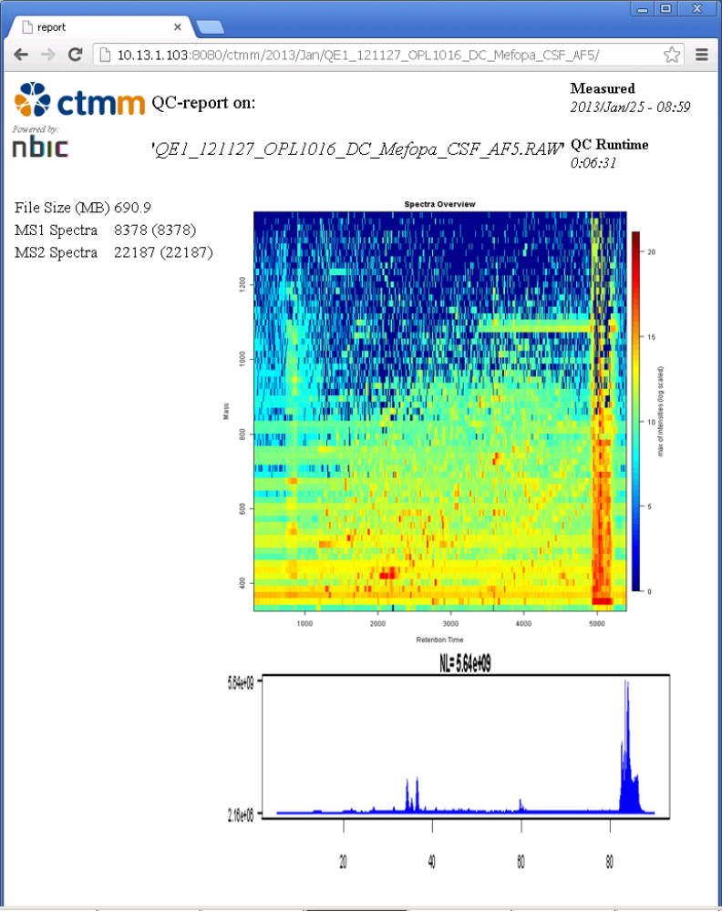
Figure 1: Example of web output of NBIC-NIST MSQC pipeline processing

Part 3: User Guide – MSQC Report Viewer

Description
The custom-made MSQC Report Viewer aggregates and shows all available QC reports from the MSQC pipeline report directory. It includes functionality of sorting, filtering, zooming and comparing these reports as per the need of proteomics researchers. The part 3 of this document – titled User Guide – MSQC Report Viewer provides instructions for installing and running MSQC report viewer.

Download Location
Project homepage: https://trac.nbic.nl/svn/proteomics/ProteomicsQCReportViewer
SVN Repository: https://trac.nbic.nl/svn/proteomics/ProteomicsQCReportViewer
Checkout project files (HEAD revision) in a folder <_REPORT_VIEWER> on your local computer. E.g. C:\ ProteomicsQCReportViewer. The project files also include runnable JAR file named ProteomicsQCReportViewer.jar. Verify that the <_REPORT_VIEWER> directory also contains following files/folders:
- appProperties
- images/na.jpg
- images/opllogo.jpg
- QCReports (Folder containing sample MSQC reports)

System Requirements and Dependencies
The MSQC Report Viewer is designed to run on top of Java Virtual Machine (JVM). It is required to install latest version of Java Development Kit (JDK) prior to using MSQC Report Viewer. Add location of <JAVA_HOME>\bin\java.exe in the system environment variable PATH. E.g. C:\Program Files\Java\jdk1.7.0_15\bin
Table 5: System requirements and dependencies

Dependencies | Link | Explanation
JDK | http://www.oracle.com/technetwork/java/javase/downloads/index.html | MSQC Report Viewer is developed using Java as a programming language. JVM is required to run programs written in Java.

Installation Procedure
The installation procedure requires that the system requirements are followed and all the dependencies are installed. Perform instructions in Step 1 – Step 6 for installing the NBIC-NIST MSQC Pipeline.
Setup
Step 1: Download HEAD revision of the project ProteomicsQCReportViewer in a folder <_REPORT_VIEWER> from the following SVN repository:
- https://trac.nbic.nl/svn/proteomics/ProteomicsQCReportViewer
Step 2: Configure properties in file appProperties as follows:
Table 6: Configurable properties in the MSQC Report Viewer appProperties file

Property name and description | Default Value | Acceptable Values
RootFolder  (folder containing MSQC pipeline output reports) | C\:\\Program Files (x86)\\Apache Software Foundation\\Apache2.2\\htdocs\\ctmm | The folder containing MSQC pipeline output reports. The reports directory has following three levels:  Year <YYYY>: e.g. 2013  Month <MMM>: e.g. Mar  Msrun reports folder: e.g. QE1_121127_OPL1016_DC_Mefopa_CSF_AF5
ShowReportsFromDate  (The date from which to show reports) | <none> | <none> represents empty string. In this case reports from previous two weeks (14 days) are shown. Acceptable format for the date is DD/MM/YYYY. E.g. 13/03/2013
ShowReportsTillDate (The date till which to show reports) | <none> | <none> represents empty string. In this case today’s date is assigned for including reports to show. Acceptable format for the date is DD/MM/YYYY. E.g. 13/03/2013
Server  (The IP address or domain name of the server running Apache Web Server) | 10.13.1.103 | In OPL, the MSQC Pipeline and Report Viewer are hosted on server 10.13.1.103. Change this value according to your organizational settings.

Step 3: Open command prompt and run following commands to see the Report Viewer output:
- cd <_REPORT_VIEWER>
- java –jar ProteomicsQCReportViewer; where
  - <_REPORT_VIEWER> is the directory where project files are checked out.

Running the MSQC Report Viewer
Open command prompt and run following commands to see the Report Viewer output:
- cd <_REPORT_VIEWER>
- java –jar ProteomicsQCReportViewer, where
  - <_REPORT_VIEWER> is the directory where project files are checked out.

Known Issues and Troubleshooting
Table 7: Known issues and troubleshooting

Issue | Pipeline Output | Troubleshooting
java.lang.OutOfMemoryError: Java heap space | Exception in thread "AWT-EventQueue-0" java.lang.OutOfMemoryError: Java heap space | Depending on the number of QC reports, the QC Report Viewer needs additional memory.  The following two options are to be used while running report viewer:  Java VM options  -Xms<size> set initial Java heap size  -Xmx<size> set maximum Java heap size  e.g.  java –Xms256M –Xmx2042M –jar ProteomicsQCReportViewer

Description of Output
Initial dialog: This dialog states that the report viewer is reading reports from preconfigured report directory. The reports directory has following three levels:
- Year <YYYY>: e.g. 2013
- Month <MMM>: e.g. Mar
- Msrun reports folder: e.g. QE1_121127_OPL1016_DC_Mefopa_CSF_AF5
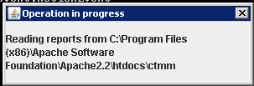
Figure 2: Operation in progress dialogue

MSQC Check Warning Messages dialog: This dialog informs the user about any missing QC report files from the report directory. The reasons behind missing QC report file is that QC Pipeline did not successfully complete QC processing of the given RAW file. In this case, check for possible errors in the RAW file.
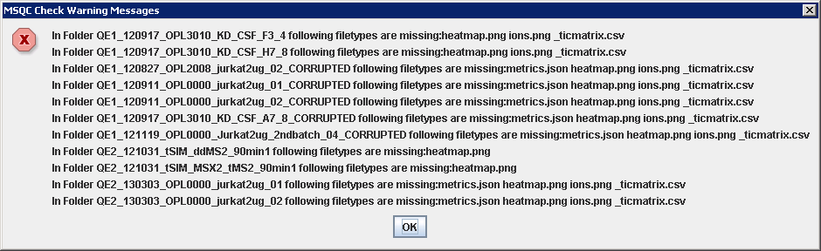
Figure 3: MSQC check warning messages dialogue

Main user interface: The main user interface is divided into three panels – control panel, reports panel and TIC panel. The control panel provides options to sort and zoom reports displayed in the report panel. The report panel displays available QC reports along with the values of calculated QC metrics. The TIC panel displays larger TIC graph corresponding to QC report selection in report panel. The description of these panels and corresponding options is given in Table 8.
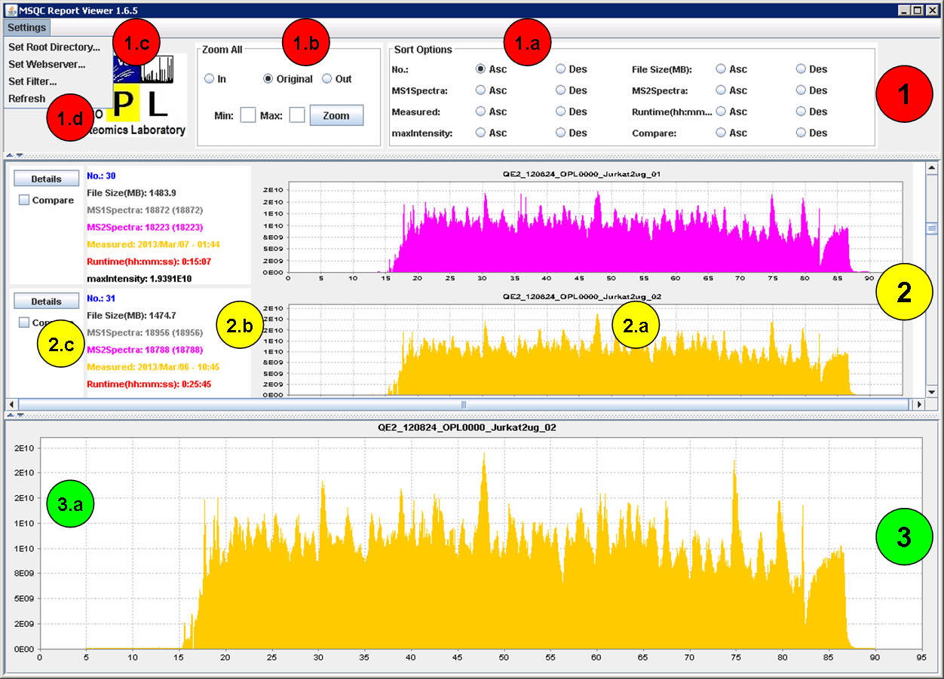
Figure 4: Main user interface of MSQC report viewer

Table 8: Description of options in MSQC report viewer

UI Item | Description
1.a: Sort options | The reports displayed in report panel can be sorted in Ascending and Descending order according to the values of following parameters in QC report:  No. -> Report number  MS1Sepctra -> Number of MS1 scans  MS2Spectra -> Number of MS2 scans  Measured -> The date and time of generating QC report  maxIntensity -> Maximum ion intensity according to the TIC graph  File Size (MB) -> The size of input RAW file for which QC report is generated  Runtime(hh:mm:ss) -> The runtime of QC pipeline processing for a particular RAW file  Compare -> Mark the QC report for comparison with other reports
1.b: Zoom All | Zoom All In -> Clicking this will zoom in (expand) all TIC graphs in report panel and TIC panel along X axis (MS Runtime in minutes)  Zoom All Original -> Clicking this will show original TIC graphs in report panel and TIC panel  Zoom All Out -> Clicking this will zoom out (shrink) all TIC graphs in report panel and TIC panel along X axis (MS Runtime in minutes)  Zoom to Range Min Max -> Clicking on Zoom button will result in zooming all TIC graphs in report panel and TIC panel – such that Min and Max represent range of X axis in minutes. In case of invalid Min and Max values, range 10 – 80 minutes will be used as the range of X axis.
1.c: Logo | Logo of the organization using the QC report viewer.
1.d: Settings – Set Root Directory… | 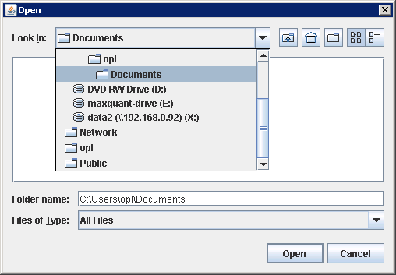  Selecting this option closes existing instance of report viewer and displays directory chooser to select QC reports from. On selecting directory that do not contain QC reports, following error message is displayed:  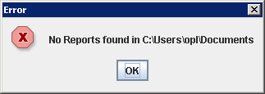  If the report directory contains QC reports, a new instance of report viewer is generated that shows the reports from selected report directory.
1.d: Settings – Set Webserver… | 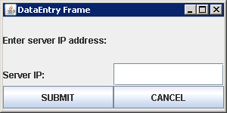  Selecting this option closes existing instance of report viewer and displays data entry frame to enter server IP address. This is the IP address/domain name of the server hosting _WEB_DIR pointing to the Apache htdocs/ctmm folder. This value will be used to create direct link to detailed QC report hosted on the webserver.
1.e: Settings – Set Filter… | 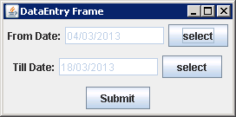  Selecting this option closes existing instance of report viewer and displays data entry frame to choose From and Till date – for limiting number of reports to be shown in report panel. On selecting appropriate dates, a new instance of report viewer is generated – that displays QC reports fitting in the date filter criteria.
1.f: Settings _ Refresh | Selecting this option closes existing instance of report viewer and creates a new instance of report viewer that also displays newly generated QC reports from the report directory.
2.a: Embedded TIC graph | This area shows TIC graph based on values of TIC matrix generated by QC pipeline.
2.b: QC metrics values | This area shows values of following parameters as obtained from QC report: File Size (MB), MS1Spectra, MS2Spectra, Measured, Runtime(hh:mm:ss) and maxIntensity. In case of missing QC report files, -1 or empty values are shown for corresponding parameters as follows:  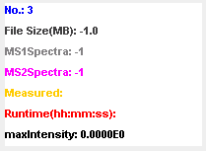
2.c: Details button | Selecting this option will open default web browser with direct link to the report such as: http://10.13.1.103:8080/ctmm/2013/Jan/QE1_121127_OPL1016_DC_Mefopa_CSF_AF5/
2.c: Compare checkbox | Selecting the checkbox corresponding to a particular QC report means the report is to be compared with other reports which also have corresponding checkbox selected. The checkbox selection should be followed by the use of Sort option – according to Compare flag.

References
- Köcher, T., Pichler, P., Swart, R. and Mechtler, K., Quality control in LC-MS/MS, Wiley Proteomics, 11(6), pp. 1026-1030, Feb 2011.
- PRIME-XS-Deliverable 13.1, Deliverable 13.1 - Suite of tools that allow automatic quality control on the acquired data, 16 Feb 2012.
- NIST LC-MS/MS Metrics for Monitoring Variability in Proteomics Experiments, National Institute of Standards and Technology - United States Department of Commerce, June 2011, available online: http://peptide.nist.gov/metrics/, last accessed: 22 Jan 2013.
- Rudnick P. A. et. al., Performance Metrics for Liquid Chromatography-Tandem Mass Spectrometry Systems in Proteomics Analyses, Molecular and Cell Proteomics, 9(2), pp. 225–241, Feb 2010.

